Multiple Choice Questions

- Decide which of the choices best completes the statement or answers the question.
- Locate that question number on the separate answer sheet provided.
- Use the procedure described by your teacher to answer each question. For example, “fill in the circle that corresponds to your choice” or “make an X over the letter corresponding to your choice.”

1. Identify the statement that best compares sensation to perception.
a. Sensation occurs when nerve impulses from the sense organs reach the cerebral cortex; perception is an interpretation by the brain of the meaning of sensations.
b. Sensation occurs when nerve impulses from the sense organs reach the spinal cord; perception is an interpretation by the spinal cord of the meaning of sensations.
c. Sensation occurs when nerve impulses from the sense organ bypass the spinal cord and go directly to the brain; perception is an interpretation by the sensory receptors of the meaning of sensations.
d. Sensation occurs when nerve impulses from the sense organs reach the cerebral cortex; perception is an interpretation by the peripheral nervous system of the meaning of sensations.

2. You walk into a pizza restaurant and immediately notice the smells associated with cooking pizza. After a few minutes, you no longer notice these odours. This phenomenon can be explained by a process called
a. sensory accommodation.
b. a reflex arc.
c. sensory adaptation.
d. an action potential.

3. Which of the following is an INCORRECT match between the sensory receptor and the stimulus that it responds to?
a. photoreceptor—light energy
b. chemoreceptor—pressure
c. mechanoreceptor—sound waves
d. thermoreceptor—change in radiant energy

4. Olfactory receptors and sound receptors both have cilia, and they both
a. are chemoreceptors.
b. are a part of the brain.
c. are mechanoreceptors.
d. transduce one form of energy from a specific stimulus into electrochemical energy.

Use the following diagram to answer the next two questions.
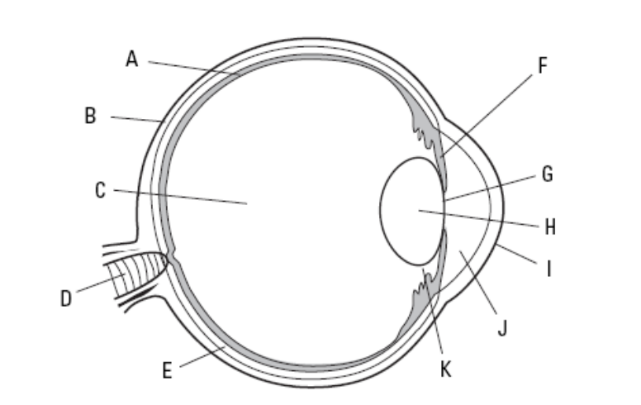

5. Which row in this chart does not correctly match the label for the name of the structure as well as its function?

Row | Label | Name of Structure | Function
a. | F | iris | regulates the amount of light that enters the eye
b. | H | lens | bends and focusses light onto the fovea centralis
c. | A | retina | contains the photoreceptor cells
d. | K | ciliary muscles | muscles responsible for light adaptation in the eye

6. The structure that would be associated with focussing light rays is labelled
a. I: cornea.
b. E: choroid layer.
c. H: lens.
d. D: optic nerve.

Use the following information to answer the next two questions.
Olfaction, the act or process of smelling, is a dog’s primary sense. A dog’s sense of smell is said to be a thousand times more sensitive than that of humans. In fact, a dog has more than 220 million olfactory receptors in its nose, while humans have only 5 million. A bony sub-ethmoidal shelf, which is found below the ethmo-turbinate bones of the nasal cavity, forces inhaled air into the olfactory epithelium. Washing out of the region upon exhalation does not occur due to the nasal pocket created by the bony sub-ethmoidal shelf. The nasal pocket permits the odour molecules that are unrecognizable in a single sniff to accumulate and interact with olfactory receptors. Odour molecules in the olfactory epithelium of the nasal cavity are absorbed into the mucous layer and diffuse to the cilia of receptor neurons. This interaction generates nerve impulses that are transmitted by the olfactory nerves to the dog’s brain, which has a well-developed olfactory lobe.

7. Which of the following is NOT a reason why most dogs have a much better sense of smell than humans do?
a. Odour molecules in the olfactory epithelium of the nasal cavity are absorbed into the mucous layer and diffuse to the cilia of receptor neurons.
b. A dog has more than 220 million olfactory receptors in its nose, while humans have only 5 million.
c. The nasal pocket permits the odour molecules that are unrecognizable in a single sniff to accumulate and interact with olfactory receptors.
d. A bony subethmoidal shelf, which is found below the ethmo-turbinate bones of the nasal cavity, forces inhaled air into the olfactory epithelium.

8. The olfactory receptors in a dog’s nose would be classified as
a. photoreceptors.
b. mechanoreceptors.
c. chemoreceptors.
d. proprioceptors.

Use the following information to answer the next two questions.
A cochlear implant is very different from a hearing aid. Hearing aids amplify sound. Cochlear implants compensate for damaged or non-working parts of the inner ear. When hearing is functioning normally, complicated parts of the inner ear convert sound waves in the air into electrical impulses. These impulses are then sent to the brain, where a hearing person recognizes them as sound. A cochlear implant works in a similar manner. It electronically finds useful sounds and then sends them to the brain. Hearing through an implant may sound different from normal hearing, but it allows many people to communicate orally in person and over the phone.

9. Identify the specific structure(s) in the inner ear that the cochlear implant is attempting to replace.
a. tympanic membrane
b. hair cells found on the basilar membrane
c. round window
d. ossicles (malleus, incus, stapes)

10. Identify the specific structures of the ear that have the same function as a hearing aid.
a. tympanic membrane and ossicles
b. hair cells found on the basilar membrane
c. round window and oval window
d. semicircular canals, saccule, and utricle

11. Which pair gives an INCORRECT function for the structure?
a. lens—focussing light rays on the retina
b. cones—colour vision
c. choroid layer—location of photoreceptors
d. sclera—protection

12. Which of the following structures would you NOT mention if you were tracing the path of sound waves in the ear?
a. auditory canal
b. tympanum
c. semicircular canals
d. cochlea

13. If a person wants to focus on objects that are close,
a. the suspensory ligaments must be pulled tight.
b. the lens needs to become more rounded.
c. the ciliary muscles must be relaxed.
d. the image must focus on the area of the optic nerve.

Use the following information to answer the next question.
Agnosia is a rare disorder characterized by an inability to recognize and identify objects or persons despite having knowledge of the characteristics of the objects or persons. Some people with agnosia may have difficulty recognizing the geometric features of an object or face; in other cases they may be able to perceive the geometric features but not know what the object is used for or whether a face is familiar or not.

14. The area of the brain that is most likely affected by agnosia is the
a. frontal lobe.
b. occipital lobe.
c. cerebellum.
d. parietal lobe.

15. Which abnormality of the eye is NOT matched correctly with its description?
a. astigmatism—either the lens or the cornea has an uneven curvature
b. farsightedness (hyperopia)—eyeball is shorter than usual
c. nearsightedness (myopia)—image focuses behind the retina
d. colour blindness—genetic disorder in which certain types of cones may be missing

16. Which of the following statements is INCORRECT with respect to hearing in humans?
a. The hair cells of the organ of Corti are able to distinguish both the frequency (pitch) and amplitude (intensity) of sound waves.
b. The hair cells of the organ of Corti are able to detect sound within the frequency range of 0 Hz to 20 Hz.
c. High frequency sounds most strongly stimulate the hair cells that are closest to the oval window.
d. Low frequency sounds most strongly stimulate the hair cells that are farthest from the oval window.

Use the following information to answer the next question.
Some people may experience motion sickness as they ride a roller coaster. The balance required while moving the head forward and backward is called gravitational equilibrium. This equilibrium depends on the two structures called the utricle and saccule, which together make up the fluid-filled vestibule of the inner ear. Both structures contain calcium carbonate granules called otoliths. The otoliths lie in a cupula over a layer of hair cells. When the head dips forward or back, gravity pulls on the otoliths. This puts pressure on some of the hair cells, which in turn send a neural impulse to the brain indicating the head’s position. Motion sickness occurs when the utricle and saccule send information to the brain which conflicts with signals that the eyes send to the brain.

17. The utricle and saccule are found in
a. the inner ear.
b. the semicircular canals.
c. the olfactory bulb.
d. sensory papillae.

18. Which of the following contains the sensory receptors that are responsible for detecting head and body rotation (rotational equilibrium)?
a. the outer ear
b. the semicircular canals
c. the olfactory bulb
d. sensory papillae

Use the following diagram to answer the next two questions.
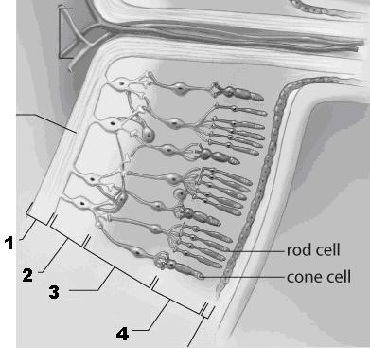

The layers of the retina in a human eye

19. Which row correctly identifies the photoreceptors in the human retina?

Row | Number
a. | 4
b. | 3
c. | 2
d. | 1

20. Which of the following statements is INCORRECT with respect to the human retina?
a. Light rays must pass through several layers of cells before reaching the rods and cones.
b. The axons of ganglion cells, which are in the layer closest to the sclera, form the optic nerve.
c. The layer that is closest to the choroid layer contains the rods and cones, which synapse with the bipolar cells of the middle layer.
d. Bipolar cells transfer a neural impulse to the ganglion cells.

Numerical Response Questions

- Record your answer on the answer sheet provided.
- If an answer is a value between 0 and 1 (e.g., 0.25), then be sure to record the 0 before the decimal place.

Use the following information to answer the next question.
Visual Interpretation

The brain integrates visual information from both eyes. The steps in the visual pathway are shown below. Please note that these steps are NOT in the correct order.

1. rods and/or cones transduce light energy into an action potential
2. nerve impulse travels to the thalamus area of the brain
3. nerve impulse travels to the occipital lobe of the cerebral cortex for interpretation
4. action potential is transferred to axons of ganglion cells
5. nerve impulse leaves eye via the optic nerve
6. light energy enters the eye and strikes the retina

1. The order in which the steps above would occur is ____, _____, _____, ______, ______, and _____. Record your 6-digit answer in the numerical response section on the answer sheet.

Use the following diagram to answer the next two questions.
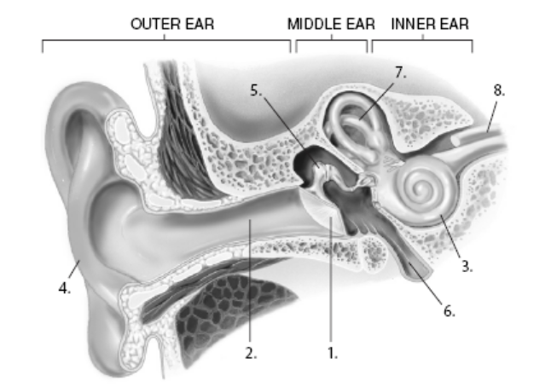

The structures in the human ear

2. List the 5 structures, in order, through which sound waves would travel on their way to the mechanoreceptors in the inner ear. Record your 5-digit answer in the numerical response section on the answer sheet.

_____ _____ _____ _____ _____

3. The structure responsible for maintaining equal air pressure between the middle ear and the outer ear and the structure responsible for maintaining equilibrium are identified by the numbers ____ and ____ on the diagram. Record your 2-digit answer in the numerical response section on the answer sheet.

Written Response Question

Answer each question in the space provided. Use complete sentences, show problem-solving methods (with formulas), and include diagrams (with labels) when required.

Use the information below to answer the following questions.
Sense of Smell

Olfactory, or smell nerve cells, are stimulated by the odours around us—the fragrance of a gardenia or the smell of bread baking. These nerve cells are found in a small patch of tissue high inside the nose, and they connect directly to the brain. Our sense of smell is also influenced by something called the common chemical sense. This sense involves nerve endings in our eyes, nose, mouth, and throat, especially those on moist surfaces. Beyond smell and taste, these nerve endings help us sense the feelings stimulated by different substances, such as the eye-watering potency of an onion or the refreshing cool of peppermint. It’s a surprise to many people to learn that flavours are recognized mainly through the sense of smell. Along with texture, temperature, and the sensations from the common chemical sense, the perception of flavour comes from a combination of odours and taste. Without the olfactory cells, familiar flavours like coffee or oranges would be harder to distinguish.

1. a) Describe the relationship between the sense of smell and the sense of taste. (2 marks)

______________________________________________________________________________
______________________________________________________________________________

b) Identify the neural pathway for your sense of taste. (4 marks)

______________________________________________________________________________
______________________________________________________________________________
______________________________________________________________________________

c) Based on the information above, explain why having a head cold or a sinus infection affects your ability to taste food. (3 marks)

______________________________________________________________________________
______________________________________________________________________________
______________________________________________________________________________
______________________________________________________________________________

Use the information below to answer the next question.
Noise-Induced Hearing Loss (NIHL)

Impulse sound can result in immediate hearing loss that may be permanent. The structures of the inner ear may be severely damaged. This kind of hearing loss may be accompanied by tinnitus, a ringing, buzzing, or roaring in the ears or head, which may subside over time. Hearing loss and tinnitus may be experienced in one or both ears, and tinnitus may continue constantly or occasionally throughout a lifetime.

Continuous exposure to loud noise also can damage the structure of the hair cells, resulting in hearing loss and tinnitus. Exposure to impulse and continuous noise may cause only a temporary hearing loss.

If the hearing recovers, the temporary hearing loss is called a temporary threshold shift. The temporary threshold shift largely disappears 16 to 48 hours after exposure to loud noise. Millions of North Americans, including individuals of all ages, including children, adolescents, young adults, and older people, can develop noise-induced hearing loss.

2. a) Identify the sensory receptors in the inner ear. (1 mark)

______________________________________________________________________________

b) Explain, in detail, how sound waves that are amplified by the ossicles in the middle ear are translated into electrochemical impulses in the inner ear. (5 marks)

______________________________________________________________________________
______________________________________________________________________________
______________________________________________________________________________
______________________________________________________________________________

c) Describe how continued exposure to loud noises can result in noise-induced hearing loss. (3 marks)

______________________________________________________________________________
______________________________________________________________________________
______________________________________________________________________________
______________________________________________________________________________

d) Why do you think so many North Americans have NIHL? (2 marks)

______________________________________________________________________________
______________________________________________________________________________
______________________________________________________________________________

e) What do you think people should do to reduce their chances of developing NIHL? (2 marks)

______________________________________________________________________________
______________________________________________________________________________
______________________________________________________________________________
______________________________________________________________________________

f) A hearing aid is a technology designed to amplify the sound waves that enter the middle ear. Why wouldn’t this technology be of much use for a person with NIHL? (2 marks)

______________________________________________________________________________
______________________________________________________________________________
______________________________________________________________________________
______________________________________________________________________________
______________________________________________________________________________
______________________________________________________________________________
______________________________________________________________________________
______________________________________________________________________________
______________________________________________________________________________
______________________________________________________________________________

